Networking in GCP
Virtual Private Cloud (VPC)
- VPC Architecture
- Subnets
- IP Addressing
Firewall Rules
Configuration
- Ingress Rules
- Egress Rules
Load Balancing
Types
- Global Load Balancer
- Internal Load Balancer
Containerization and Kubernetes
Containers Fundamentals
- Docker Overview
- Container Lifecycle
- Container Registry
Google Kubernetes Engine (GKE)
Kubernetes Basics
- Pods
- Deployments
- Services
- Ingress
Scaling
- Horizontal Pod Autoscaler
- Cluster Autoscaler
Artifact Registry
Managing Container Images

Networking in GCP
Networking in GCP refers to the services & technologies that enable communication between cloud resources, applications, users, & external networks.
Google cloud provides a secure, scalable, & high-performance networking infrastructure built on Google’s global network.
Networking is essential for connecting VMs, databases, applications, storage services, & on-premises environment.
Objectives of GCP Networking
- Connectivity
- Security
- Scalability
- Availability
- Performance
- Isolation
Major networking services in GCP
Service | Purpose
Virtual Private Cloud (VPC) | Provides an isolated, software-defined cloud network
Subnets | Divide VPCs into regional IP address ranges
IP Addressing | Identifies resources & enable network communication
Firewall Rules | Control incoming & outgoing network traffic
Cloud Load Balancing | Distributes application traffic across backend resources
Cloud DNS | Provides domain name resolution
Cloud NAT | Enables outbound internet connectivity for resources without external IP addresses
Cloud VPN | Provides encrypted connectivity between networks
Cloud Interconnect | Provides dedicated or partner-based connectivity to Google Cloud

Virtual Private Cloud (VPC)
What is a VPC?
A GCP VPC is a virtual networking environment that enables cloud resources to communicate securely. It is a software-defined network managed by Google Cloud.
A VPC provides logical network isolation while using Google’s underlying physical networking infrastructure.
Key Characteristics of VPC
- Global Resource
- Logical Isolation
- Regional Subnets
- Private Communication
- Customizable Security
- Scalable Architecture
- Hybrid Connectivity
VPC Architecture
VPC architecture consists of several networking components that work together to provide connectivity, routing, isolation, & security.
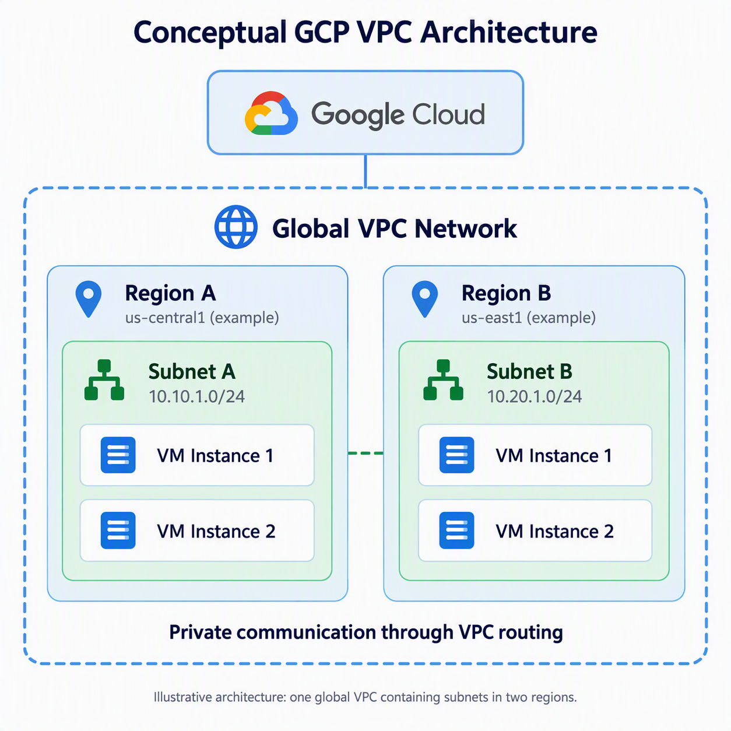
Important architectural concepts
Concept | Description
Global VPC | A single VPC can contain subnets in different regions
Regional subnets | Each subnet belongs to one region
Cross-region communication | Resources in different regional subnets can communicate using internal IP addresses when routing and security rules permit
Network isolation | Different VPCs are logically isolated unless connectivity is established
Distributed routing | Google's network infrastructure manages packet forwarding
Firewall enforcement | Traffic is evaluated against applicable security rules

Subnets
What is Subnet?
A subnet is a regional subdivision of a VPC network with a defined IP Address range. A Subnet organize network resources & provide internal IP address allocation. Each subnet belongs to exactly one VPC network & one Google Cloud region.
What’s the importance of Subnets?
- Organize resources by region, workload, or environment
- Allocate internal IP addresses
- Support network segmentation & address planning
- Reduce IP address conflicts
- Helps establish logical boundaries for network management
- Support scalable application architecture.
Subnets do not provide security isolation from one another. Firewall policies & other security controls are still required.
Types of VPC Subnet Creation Modes
- Auto Mode VPC
- Custom Mode VPC
Auto Mode vs Custom Mode
Feature | Auto Mode | Custom Mode
Subnet Creation | Automatic | Manual
IP Ranges | Predefined Initially | Administrator-defined
Flexibility | Limit | High
Network Planning | Minimal Initially | Required
Enterprise Suitability | Less Flexible | Generally Preferred
Control | Lower | Higher

IP Addressing
IP addressing is the mechanism used to identify resources & enable communication across a network. Every network interface requires an appropriate IP configuration to send & receive network traffic.
Types of IP Addresses
- Internal IP Address
- External IP Address
Static vs Ephemeral IP Addresses
Feature | Static IP | Ephemeral IP
Allocation | Reserved | Automatically assigned
Address stability | Retained while reserved | Not guaranteed to remain the same
Typical purpose | Stable service endpoints | Temporary or flexible workloads
Management | Explicit reservation and release | Managed through resource lifecycle
Cost considerations | Charges depend on IP type and usage | Charges may also apply

CIDR Notation
10.10.1.0/24
Firewall Rules
What is a Firewall Rule?
A firewall rule is a network security control that determines which traffic is allowed or denied.
How Firewall Rules Work?
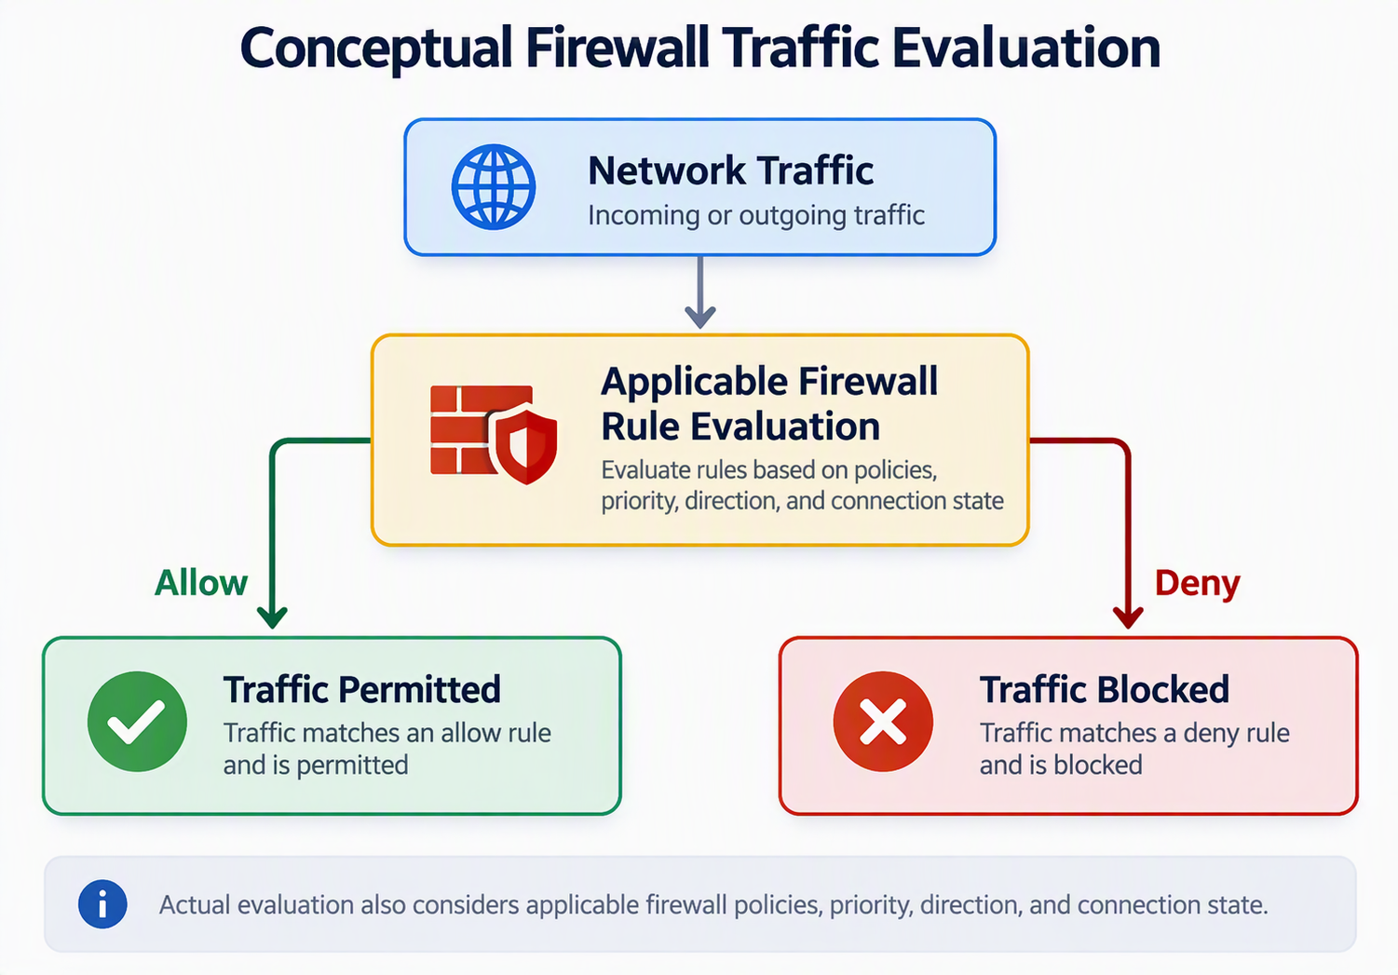
Components of Firewall Rule
Component | Description
Name | Unique identifier for the rule within its VPC
Direction | Ingress or egress
Priority | Determines rule evaluation precedence
Action | Allow or deny
Protocol | TCP, UDP, ICMP, or other supported protocols
Port | Identifies specific network services
Source/Destination | Defines the traffic origin or destination
Target | Identifies resources to which the rule applies
Logging | Records applicable firewall traffic information

Configuration
- Ingress Rules (Inbound)
- Egress Rules (Outbound)
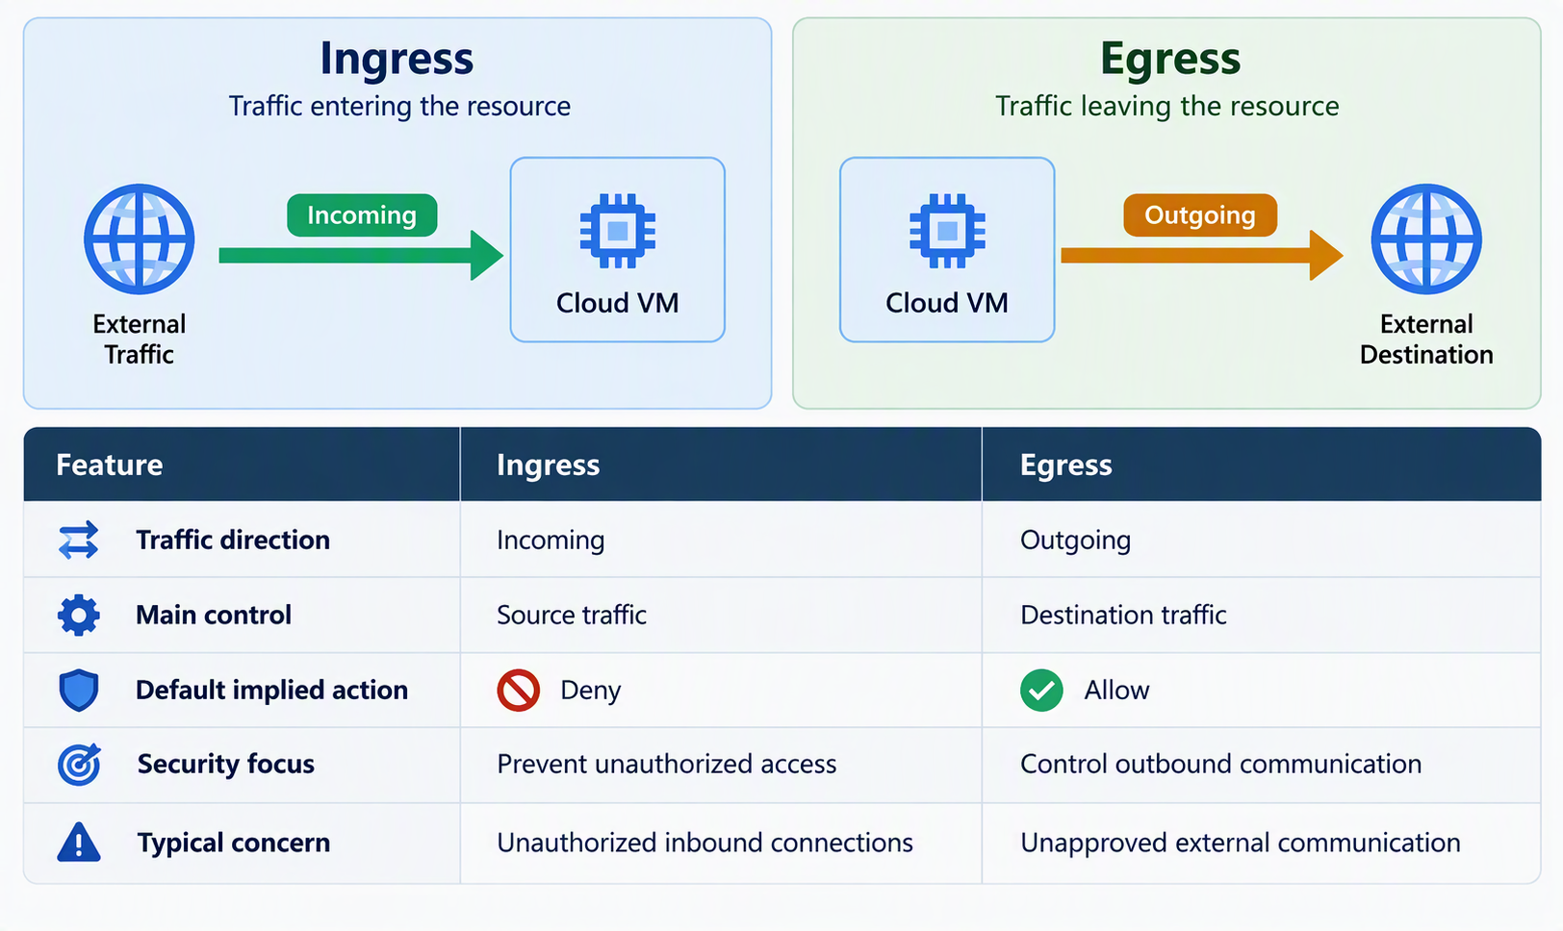
Load Balancing
What is Load Balancing?
Load Balancing is the process of distributing network or application traffic across multiple backend resources.
Objective of Load Balancing
- High Availability
- Scalability
- Performance
- Fault Tolerance
- Reliability
- Traffic Management
Load Balancer Architecture
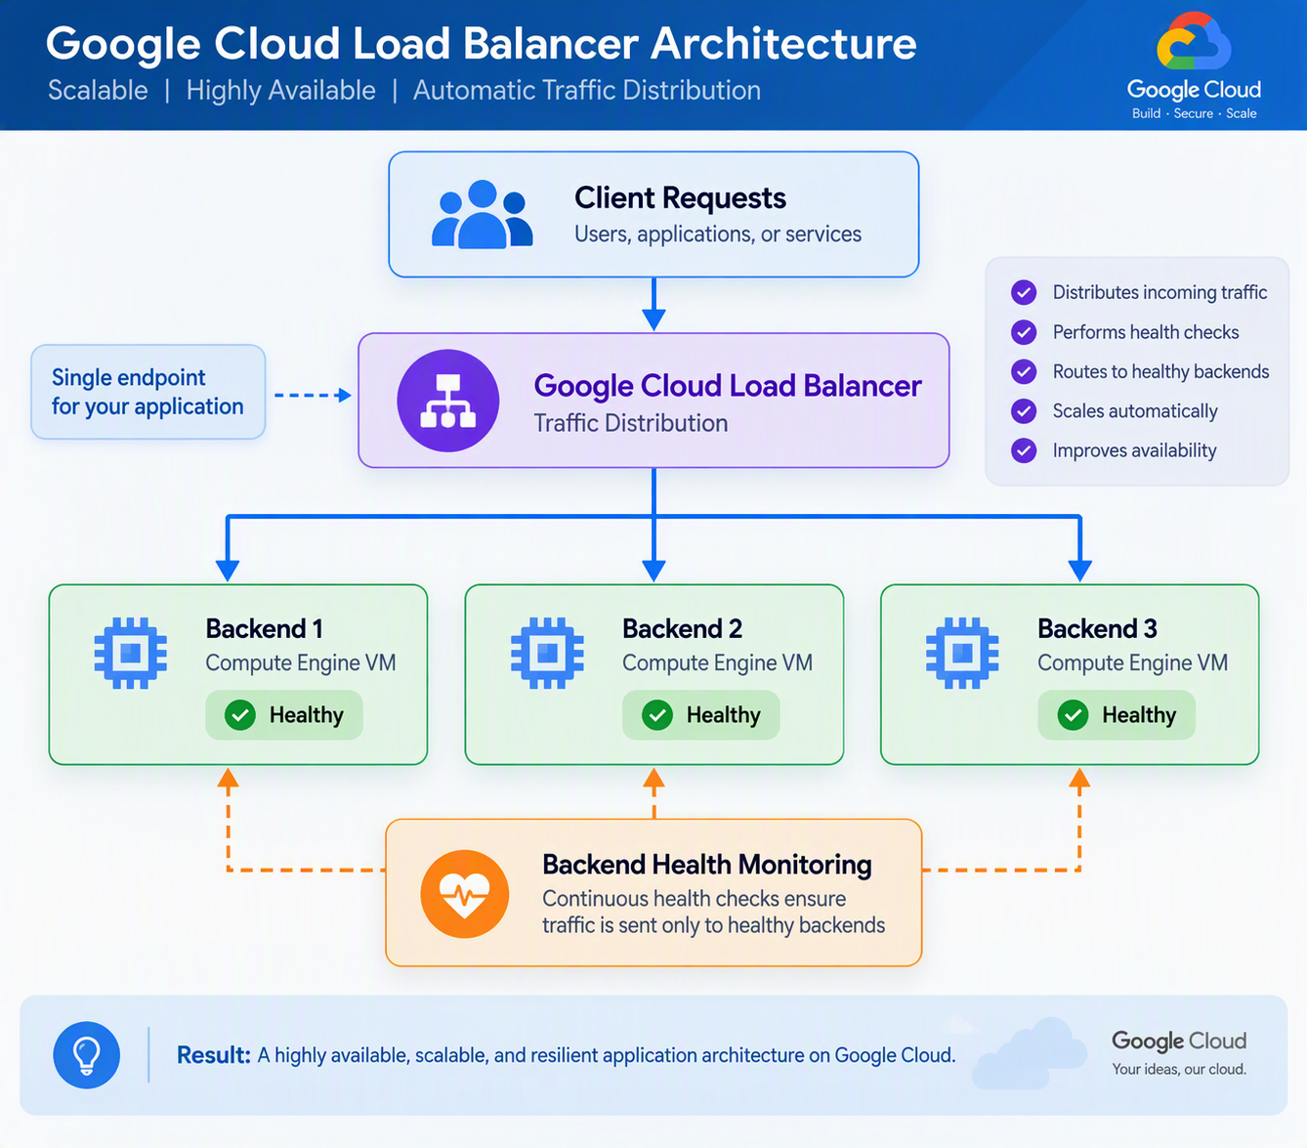
Types
- Global Load Balancer
- Internal Load Balancer

Global vs Internal Load Balancing
Feature | Global Load Balancer | Internal Load Balancer
Primary characteristic | Global geographic scope | Private frontend reachability
Frontend IP | Globally scoped, commonly external | Internal IP
Public internet access | Supported by global external types | Not directly public
Backend distribution | Can span regions | Regional or cross-region, depending on type
Typical users | Internet clients | Private network clients
Security model | Public frontend with security controls | Private connectivity with security controls
Application scope | Global applications | Internal applications and services
Common objective | Global traffic distribution | Private traffic distribution

Relationship between VPC, Subnets, Firewall Rules, & Load Balancing
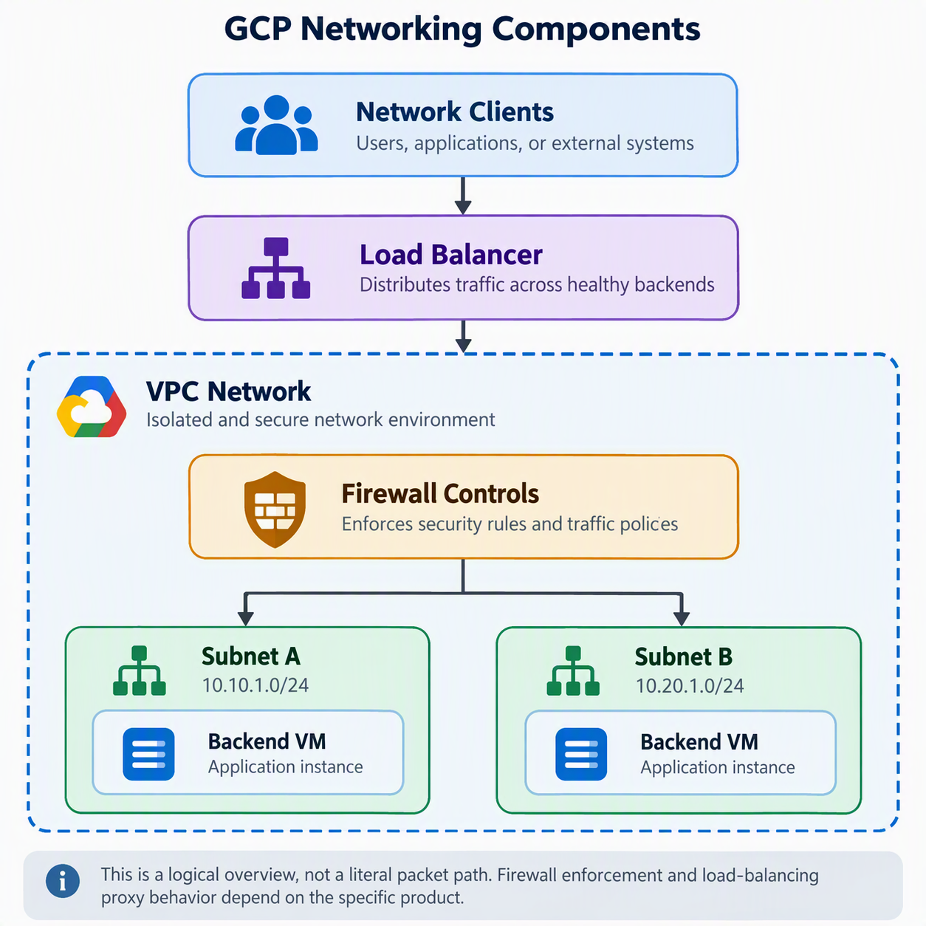
Containerization and Kubernetes
Introduction to Containerization
Containerization is a software technology that allows applications and their dependencies to be packaged into lightweight, portable, and isolated environments called containers.
A container includes everything an application needs to run, such as application files, runtime libraries, system dependencies, and configuration.
Containers help ensure that applications behave consistently across development, testing, and production environments.
Why is containerization important?
Traditionally, applications were installed directly on physical servers or virtual machines. This created several challenges, including environment inconsistencies, dependency conflicts, resource utilization, and deployment complexity.
Containerization addresses these challenges by providing:
- Portability: Applications can run across different compatible environments.
- Consistency: Applications use the same packaged dependencies.
- Isolation: Applications operate in separate environments.
- Scalability: Additional container instances can be created as demand increases.
- Resource efficiency: Containers share the host operating system kernel.
- Faster deployment: Containers generally start faster than virtual machines.
Containers vs Virtual Machines
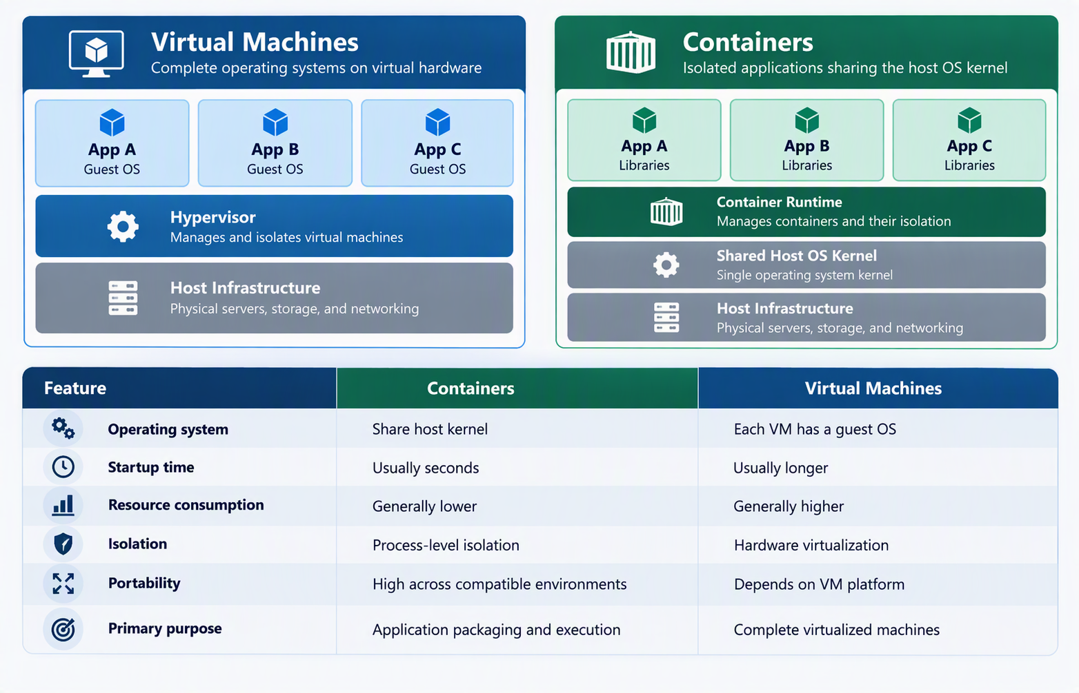

Containers Fundamentals
- Docker Overview
- Container Lifecycle
- Container Registry
Google Kubernetes Engine (GKE)
GKE is a managed Kubernetes service provided by Google Cloud.
Kubernetes Basics
- Pods
- Deployments
- Services
- Ingress
Scaling
- Horizontal Pod Autoscaler
- Cluster Autoscaler
Artifact Registry
Managing Container Images

